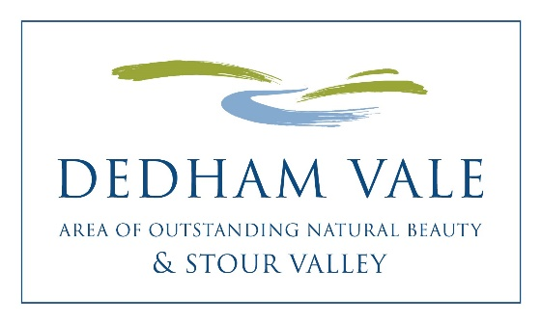
Dedham Vale AONB
Sustainable Development Fund 2018-19

Projects awarded funding
Twelve awards total £17,676

Lucinda de Jasay & Arabella Douglas-Menzies Awarded £350
Project Title: Renovate Boxted village sign
The renovation and repainting of existing Boxted Parish cast iron fingerpost sign.

Field Studies Council, Flatford Mill Awarded £1,850
Project Title: Access Improvements
To provide improved wheelchair accessible seating and engagement areas around the FSC Flatford Mill site to enable enhanced learning and conservation work areas for students.

National Trust Awarded £1,000
Project Title: Equipment training for volunteers
The Ranger team support training of some of the National Trust volunteers in some of the powered equipment used to manage sites.

Eco Club, Stoke By Nayland Primary School Awarded £438
Project Title: Re-establish the pond in the wild garden
The wild garden has a pond which the children are currently unable to use as the pond lining is split. We are re-establishing the site.

Nayland with Wissington Conservation Society Awarded £3,000
Project Title: The Court Knoll Project Phase 2 Part 3
To undertake further research into the glass, polychromatic tile and other finds at Court Knoll, to be completed before the final Full Archaeological Finds report can be prepared.

SVEN – Stour Valley Education Network Awarded £2,387
Project Title: Produce Factsheets and support outdoor events
To reprint the Stour Valley Discovery Factsheets and add a River & Management sheet, deliver a SVEN activities programme and run a big family outdoor SVEN event for the River Stour Festival.

Taste of Sudbury Community Interest Company Awarded £1,000
Project Title: Taste of Sudbury Food & Drink Festival 2018 Fringe events
To produce a short film of local fringe events that are being held in the run up to the main event and to film some shots of the main festival on Sunday June 10th with an emphasis on the importance of supporting local producers and understanding the provenance of our food.

Stuart Bowditch Awarded £1,500
Project Title: Confluent - River of Words
River of Words is a sound project that documents and shares the voices of the people that have contributed to the accessibility, conservation and beauty of the River Stour and its valley.

Tiger Hill Local Nature Reserve Awarded £3,900
Project Title: Surveys to support the next Five Year Management Plan
To help towards the cost of employing an Ecologist/ Surveyor to carry out a nature survey, and oversee, monitor, plan and implement the next 5 Year Management Plan for Tiger Hill Nature Reserve.

River Stour Festival Awarded £1,750
Project Title: Festival Journal ‘Stour Valley’
A5 publication of writing and illustrations on culture, wildlife and place celebrating the Stour Valley, providing a legacy artefact for the River Stour Festival and The River Runs Through Us project.

Leavenheath, Polstead and Stoke by Nayland Community Woodland
Awarded £501
Project Title: Rowley Wood Interpretation Board
Replacement interpretation board by the pond in Rowley Wood.

CS May 2018

