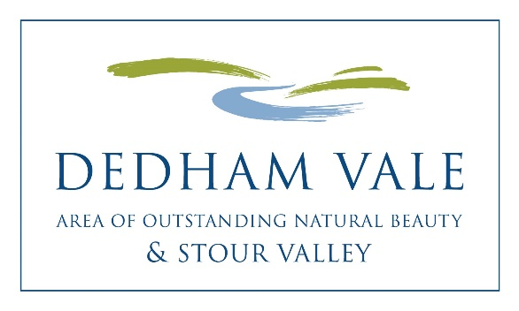
Dedham Vale AONB
Sustainable Development Fund

Projects Awarded Funding 2019-20
8 projects received a total of £18,211

1 River Stour Trust £1,280
Constable Trail: To link the locations of 12 of John Constable’s most famous paintings, allowing visitors to better understand his work, and introducing them to the River Stour and Dedham Vale which inspired his work.

2 Nayland with Wissington Conservation Society £2,663
Court Knoll Project Phase 2 Part 4: Following the excavation of seven trenches on the listed ancient monument known as Court Knoll the substantial number of finds need to be catalogued and assessed for significance and a report prepared thereon.

3 Outside in Nature £2,286
Outside in Nature: To offer one to one outdoor therapy, combing Reality Therapy and Choice Theory with guided reflection and activities outside in nature to promote health and wellbeing.

4 Taste of Sudbury Community Interest Company £1,032
Taste of Sudbury cotton bags: To reduce the amount of plastic that is used by stallholders, we will buy 2000 cotton shopper bags that can be given out, free of charge, to visitors at Taste of Sudbury Sunday 9 June, by stallholders and volunteers.

5 Field Studies Council, Flatford Mill £5,250
River Stour Biodiversity Awareness for the Local Community: To promote and improve knowledge of the river and biodiversity to 750 local school children and their families by offering subsidised first-hand educational experiences along the river, and provide information and guidance on how to engage, experience and support the area in the future.

6 East Bergholt Futures £500
Promotion of sustainable and reusable coffee cups: Buying and promoting reusable and sustainable coffee cups in Dedham Vale to reduce litter and plastic use.

7 Suffolk Bat Group £1,000
Harp trap survey equipment: To purchase specialist bat surveying equipment (two harp traps, acoustic lures and associated equipment) to conduct long-term monitoring of bat populations.

8 Stour Valley group/Dedham Vale AONB £4,200
Improving the Stour Valley for Visitors: To enhance activities and opportunities as part of “Improving the Stour Valley for Visitors”, a project (2019-20) that has secured funding from LEADER, such as footpath improvements, a film featuring ‘Art at the Heart of the Valley’, and production of local guides.

Cathy Smith 1 May 2019

