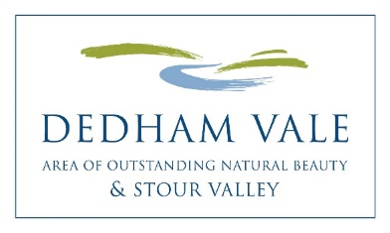
Dedham Vale Area of Outstanding Natural Beauty (AONB)
Sustainable Development Fund
Projects awarded funding 2020-21

10 projects = £21,870

1 Field Studies Council Flatford Awarded £2,250
Environmental and Personal Awareness Programme
To provide new outdoor classroom spaces and resources around the grounds of the Field Study Centre to help promote personal, social and environmental awareness within individuals.

2 Nayland with Wissington Conservation Society Awarded £1,517
Stour Valley Path Improvement at Nayland
The improvement of a section of the Stour Valley footpath on the south side of the River Stour at Nayland, by installing steps.

3 Stoke By Nayland Primary School and Nursery Awarded £3,430
Outdoor Learning
Continue to develop, expand and enhance the ‘Outdoor Learning Areas’ for the benefit of the Children, Wildlife, School and Local Community. To increase the children’s connection with nature, engages the whole school with varied approaches to learning.

4 Sudbury Canoe Club Awarded £520
Recreational river trips by Canoe or Kayak
Funding for Canoe and Kayak instructors to acquire the necessary qualifications to lead, coach and provide safety cover for recreational river trips on the river Stour from Sudbury to Cattawade.

5 Abberton Rural Training (ART) Awarded £894
Equipment for rural training
To purchase a water collection system and wheelbarrows for rural training activities for young people who are NEET and people with lifelong conditions, mental health issues, physical and learning disabilities, for their Wormingford base.

6 Nayland Land Company Awarded £1,570
Nayland Conservation Field Improvements
To install fencing to protect a newly laid hedge, realign a footpath to create a small woodland including planting, to manage the area, to sign as a Permissive Path, and to inform the community and visitors of what the project is achieving.

7 Suffolk Wildlife Trust Awarded £4,190
Water vole recovery network on the river Stour
Our 2018 Stour water vole survey highlighted that the populations are very vulnerable to predation, which this co-ordinated approach with the farm cluster will address.

8 The Bench Project Awarded £1,000
Munnings Museum Bench Project
To design a unique, well-being bench installation for the Munnings Museum’s grounds in creative workshops with the museum’s stakeholders. Local craftsmen will use eco-friendly local oak and galvanised steel for longevity.

9 Dedham Vale AONB & Stour Valley Awarded £4,749
Improving the Stour Valley for Visitors
To enhance activities and opportunities as part of “Improving the Stour Valley for Visitors”, a project (2019-20) that has secured funding from LEADER, such as production of podcasts and local guides.

10 River Stour Festival Awarded £1,750
2021 Programme
To enhance, deliver and promote the events and activities that will make up the 2021 programme of the River Stour Festival.

