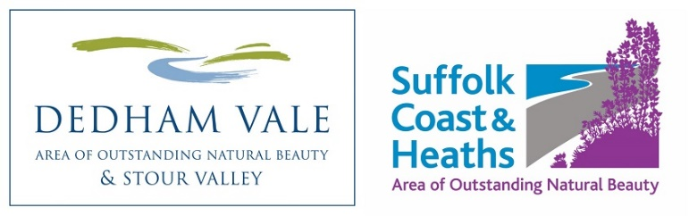
Dedham Vale AONB and
Coast & Heaths AONB
Sustainable Development Fund
2021 – 2022 Application Form

PLEASE COMPLETE ALL SECTIONS OF THE APPLICATION FORM AND RETURN By end of day on Monday 17 May 2021.

Which AONB are you applying to? ………………………………………………..
If you wish to apply to both AONBs for projects please fill in separate application forms – your budget should be presented separately and you should have different AONB-specific objectives or activities.

1. Name of Project

2. Name of Organisation/Group

Relevant website address

3. How much is your funding request?

4. Short Summary of Project
(Approximately 20-30 words)

5. Contact Details

MAIN CONTACT:
Name
Address/Postcode

Phone/Mobile
Email

Additional CONTACT:
Name

Phone/Mobile
Email

6. Details of Project
Please cover the range of information indicated below and keep to under two pages.
You are welcome to include photos.

- What is the overall aim(s) of the Project?
- Why is this project needed and by whom?
- Describe the work/activity you will be doing and with whom
- Who will lead the activities and who will be involved in the project (such as volunteers)?
- Is this project related to another project or is further work of a recent project?
- What is the planned outcome/what will be the finished project?

7. Location/Grid Reference or Address of Project:
Enclose or attach a map, plan or photo as necessary

8. Project Timetable
Please provide estimated start and end dates, key event/activity dates
Note – the project should plan to finish by or before end March 2022

9. Name of Project Manager/Leader
Please provide details of experience/qualifications relevant to the role

10. Who/what will benefit from the project?
Who are the main targets? Will others benefit?

11. How will you measure the success of the project?
How will you know it has succeeded?

12. What Type of Organisation are you?

- A trust, charity, voluntary organisation, limited company etc

- Are you VAT registered? Yes or No

Note – see Criteria and Guidance for more about VAT terms and conditions

13. How does the project meet AONB conservation objectives
Please read the fund guidelines provided before answering this section

- Does the project conserve and enhance natural beauty and maintain the special qualities of the landscape?
- Will it help manage the assets and resources of the AONB in a sustainable way and seek to meet environmental, economic and social needs?
- Does it support community involvement in the active conservation and enhancement of the AONB

14. Project Budget

Notes:
- Grants are offered for up to 70% of the project costs.
- Match funding can include a value for voluntary activity. Please contact the AONB Grants Officer for guidance on budget values that can be attributed to volunteer hours ‘in kind’ contribution.
- In both Dedham Vale and Coast & Heaths AONBs, where projects are seeking a grant up to/in the region of £500, organisations can apply for 100% of the total costs.

a) Total cost of the project -----------------------------

b) How much is already in place -----------------------------

c) Total outstanding amount -----------------------------

d) Amount of grant requested -----------------------------

You are required to include a breakdown of your (estimated) project costs and match-funding – please attach or insert a spreadsheet (up to one page) at the end of the application form. Below is an example of the type of table that is useful for the Panel to consider your application.

Expenditure | £ | Note
Item 1 | 600 | 4 staff @150 per day
Item 2 | 1,350
Total | 1,950
Income | £
Source 1 | 300
Source 2 | 1,200
In Kind | 300 | 6 days unskilled volunteer time @50 per day
Total | 1,800
Grant request | 150

15. Additional budget and funding information:

- How much volunteer time may support the project?

- How will you fund the balance (if not explained above)?

- If only partial funding is available, which elements of the project would be given priority?

15. Where did you hear about this grant giving programme?

Declaration:
- I have read the Guidelines and Criteria, and accept unconditionally the Terms and Conditions
- I have authority from the organisation named in Section 2 to submit this project to the AONB for a Sustainable Development Fund grant
- I agree that the AONB may make enquiries in connection with this application to satisfy itself about relevant financial and legal matters
- I confirm that the details as set out in this application are correct to the best of my knowledge and that nothing material affecting this project has been withheld

Signed ………………………………………………….. Date

Name (please print) …………………………………………………

On behalf of …………………………………………………………

Please send your completed application form by end of day on Monday 17 May 2021:

AONB Grants Officer
Sustainable Development Fund
Dedham Vale AONB/Coast & Heaths AONB
Dock Lane, Melton, Woodbridge, Suffolk IP12 1PE
Tel: 01394 445225
Email: AONBgrants@suffolk.gov.uk
OL Feb 2021

