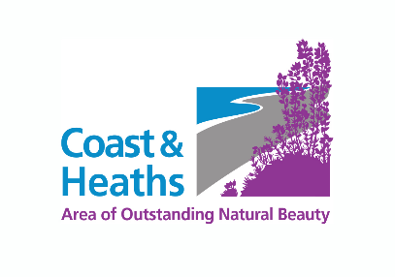
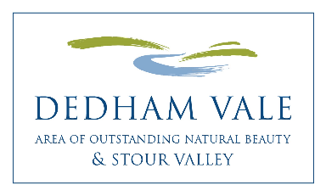

Coast & Heaths Area of Outstanding Natural Beauty
Dedham Vale Area of Outstanding Natural Beauty
Sustainable Development Fund (SDF)
2023 – 2024 Application Form

Please complete all sections of the Application Form and return by
19th May 2023, 11:59pm

Before filling in the Application Form, please read through:
- Funding Criteria and Guidance Notes for Applicants 2023-24
- SDF Publicity Guidance for grant funded projects
- Case studies of previously funded SDF projects on the respective AONB website

Applications submitted by e mail and typed are welcomed. If handwriting, please use continuation sheets where there is not enough space to write.

Which Area of Outstanding Natural Beauty (AONB) are you applying to?
(delete as applicable)

Coast & Heaths AONB / Dedham Vale AONB

NB If you wish to apply to both AONBs for projects please fill in separate Application Forms. Your budget should be presented separately and you should have different AONB-specific objectives or activities.
1. Name of Project

2. Name of Organisation/Group
Please give the name of the organisation or individual who will be responsible for the
project and financially accountable for how funds will be spent.

Relevant website address
3. How much is your funding request?

4. Short Summary of Project
(Approximately 20-30 words)

5. Contact Details
Main Contact:
Name
Address/Postcode
Phone/Mobile
Email

Additional Contact:

Name
Phone/Mobile
Email

6. Details of Project
Please cover the range of information indicated below and keep to under two pages.
You are welcome to include photos.

- What is the overall aim(s) of the Project?
- Why is this project needed and by whom?
- Describe the work/activity you will be doing and with whom
- Who will lead the activities and who will be involved in the project (such as volunteers)?
- Is this project related to another project or is further work of a recent project?
- What is the planned outcome/what will be the finished project?

7. Location/Grid Reference or Address of Project
Enclose or attach a map, plan or photo as necessary.
NB You can check the AONB boundaries by searching for your project location on
Google Maps where the approximate location of both AONBs are shaded green.
With borderline locations, or if you are unsure whether your application is
geographically eligible, please contact the AONB to confirm before applying.

8. Project Timetable
Please provide estimated start and end dates, key event/activity dates
NB The project should plan to begin from August 2023 onwards, and be
completed by or before 13 March 2024.

9. Name of Project Manager/Leader
Please provide details of experience/qualifications relevant to the role

10. Who/what will benefit from the project?
Who are the main targets? Will others benefit?

11. How will you measure the success of the project?
- How will you know it has succeeded?
- What are your measurable achievements? e.g. volunteer numbers/hours, people involved, trees planted, nest boxes installed etc.

12. What Type of Organisation are you?

- A trust, charity, voluntary organisation, limited company etc.

- Are you VAT registered? (delete as applicable) YES/NO

NB Applicants need to have their own bank account for full grant payment to be invoiced from and paid into. If this is not possible, you may request below to nominate a partner organisation to provide a bank account for project purposes.

- I/We hereby request to nominate a partner organisation to provide a bank account for project purposes.

Organisation name
Address
Contact name
Contact e mail

13. How does the project meet AONB conservation objectives
- Does the project conserve and enhance natural beauty and maintain the special qualities of the landscape?
- Will it help manage the assets and resources of the AONB in a sustainable way and seek to meet environmental, economic and social needs?
- Does it support community involvement in the active conservation and enhancement of the AONB

14. Project Budget
NB To complete this Section, it is essential to refer to Funding Criteria and Guidance Notes for Applicants 2023-24:
- Section 3 - How much can you apply for?
- Section 12 Project Budget - What the applicant contributes, VAT and Budget presentation
- Includes EXAMPLE project budget format that must be used to present your budget to the Panel

a) Total cost of the project -----------------------------

b) How much is already in place -----------------------------

c) Total outstanding amount -----------------------------

d) Amount of grant requested -----------------------------

You are required to include a Project Budget - a breakdown of your (estimated) project costs and matching contributions. Please attach or insert a spreadsheet (up to one page) at the end of the application form. In addition, you are required to format your budget the same as the example project budget provided.

NB SDF cannot meet VAT costs for VAT registered organisations, therefore if you are VAT registered – please use figures excluding VAT in your project budget calculations.

15. Additional budget and funding information

- How much volunteer time may support the project?
If not already explained in your project budget please include roles to be undertaken and estimated time.

- How will you fund the balance (if not explained above)?
Describe any alternative means for your project to provide matching contributions,
if necessary, to fully complete the project e.g. core funds, fundraising, matching
partner contributions, other grants etc.

- If only partial funding is available, which elements of the project would be given priority?

16. Where did you hear about this grant giving programme?

Declaration:
- I have read the Criteria and Guidance, and accept unconditionally the Terms and Conditions
- I have authority from the organisation named in Section 2 to submit this project to the AONB for a Sustainable Development Fund grant
- I agree that the AONB may make enquiries in connection with this application to satisfy itself about relevant financial and legal matters
- I confirm that the details as set out in this application are correct to the best of my knowledge and that nothing material affecting this project has been withheld
- I understand that my details will be stored securely for AONB purposes only and will not be shared externally.

Signed ………………………………………………….. Date …………………..

Name (please print) …………………………………………………

On behalf of …………………………………………………………

Please submit your completed application form by 19th May 2023, 11:59pm:

Application by e mail is encouraged: AONBgrants@suffolk.gov.uk

AONB Grants Officer
Sustainable Development Fund
Dedham Vale AONB/Coast & Heaths AONB
AONB Office, Saxon House, Hadleigh Road Industrial Estate, Ipswich IP2 0UF
Tel: 01394 445225

suffolkcoastandheaths.org dedhamvalestourvalley.org

OL Dec 2022

